My market

Technical Solution Description

Table of contents
1. Overview 3
2. Frameworks and technologies used 4
3. Project model 5
3.1. Basic entities 5
3.2. Functionality 8
4. Implementation 8
4.1. Database 8
4.1.2. Entities 10
4.1.3. DAO 11
4.1.4 Business logic 11
4.1.5 UI 12
5. Testing 12
6. Features 13
7. Security 13
8. Logging 13
9. Deployment 14

1. Overview
My market is a web application that simulating the operation of the information system of an on-line store.
Application allows authorized users perform some actions based on their roles. User can browse the catalog with the ability to filter by parameters, create order, change personal info, view history of orders. Managers are responsible for creating a product, change products, change orders status (shipped \ delivered \ return), browse sales statistics (top 10 products, customers, monthly / weekly revenue).
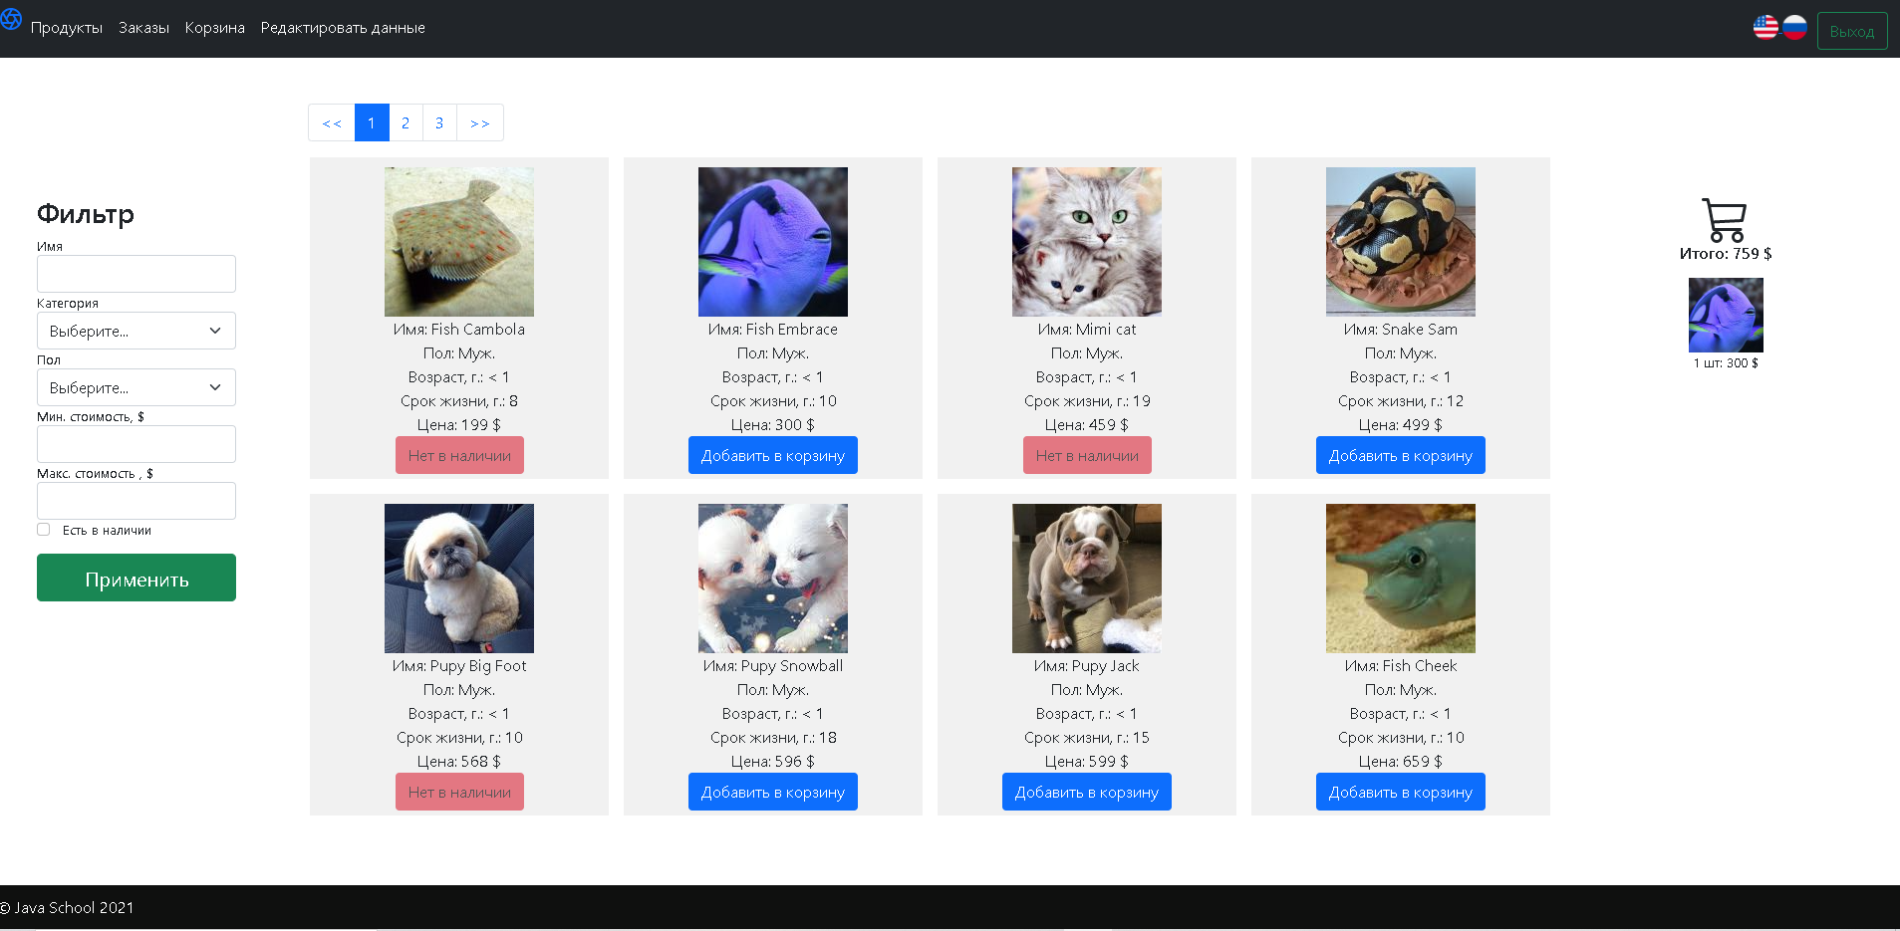
Figure 1. Main page of the application.

2. Frameworks and technologies used
- Java 8
- IntelliJ IDEA Ultimate
- Spring 5.0.6 RELEASE
- Junit 2.17.0
- Slf4j 1.7.30
- Hibernate 5.4.1 Final
- MySQL 8
- JSP 2.3
- Mockito 3.7.7
- Flyway 4.0.3
- Jquery 3.1.1
- JSTL 1.2
- Bootstrap 5
- Maven 3.6.3
- Tomcat 9.0.41
- RabbitMQ 5.12.0

3. Project model

3.1. Basic entities
These entities are essential to application’s work:
- User
  - User ID
  - First name (nickname)
  - Last name
  - Password(bcrypt)
  - Email
  - Birthday
  - Address
  - Role
- Product
  - Product id
  - Product title
  - Product price
  - Category id
  - Parameters id
  - Foto id
  - Quantity
- Cart
  - Cart id (uuid)
  - List of cart items
  - Price
  - User (owner)
- Cart item
  - Cart item id
  - Cart id
  - Product id
  - Quantity
  - Price per product
  - Cart item price
  - Created at
- Order
  - Order id (uuid)
  - List of order items
  - User (owner)
  - Price
  - Address
  - Payment method
  - Delivery method
  - Order state
  - Created at
- Order item
  - Order item id
  - Order id
  - Product id
  - Quantity
  - Price per product
  - Order item price
  - Created at
  - Order state
- Address
  - Address id
  - Country
  - City
  - Zip
  - Street
  - House
  - Flat
- Category
  - Category id
  - Category name
- Parameters
  - Parameters id
  - Product gender
  - Product age
  - Product weight
  - Product lifespane
- Role
  - Role id
  - Role name

3.2. Functionality
- For managers (using UI-interface):
  - Orders
    - View
    - Change of order status (shipped \ delivered \ return)
  - Sales statistics (top 10 products, customers, monthly / weekly revenue)
  - Products
    - Adding
    - Create and manage catalog categories
- For users (using UI-interface):
  - Browse the catalog with the ability to filter by parameters
  - Viewing and editing a profile
  - Information
    - Addresses
    - Passwords
  - Orders
    - Checkout
    - View order history

4. Implementation

4.1. Database
The database schema is shown in Figure 3 and the description of tables is listed in Table 1.
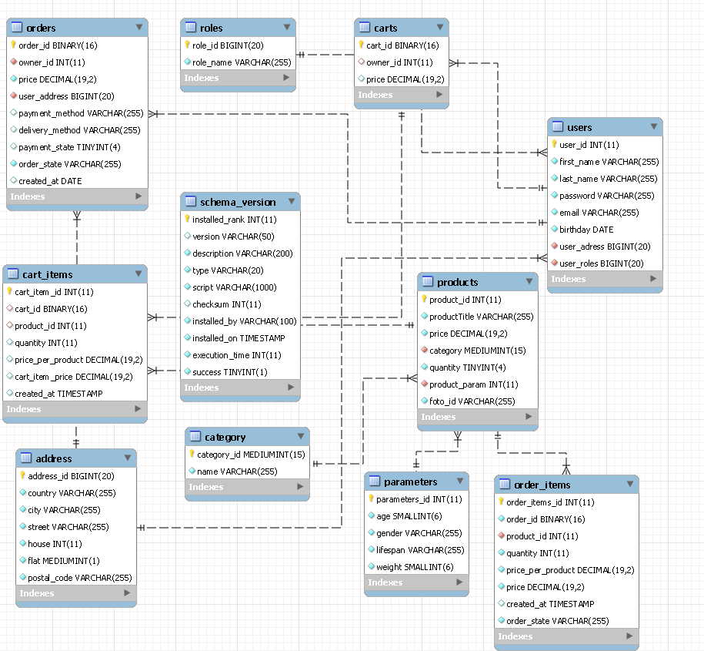
Figure 3. Database schema.
Table name | Description | Relations with other tables
users | Contains only user credentials and role – used for authorization | cart – M:1  address – M:1
carts | Information about carts | users – M:1
roles | Information about roles | users – 1:1
orders | Information about orders | users – M:1  address – M:1
order_items | Information about orders items | products – M:1  orders – 1:1
cart_items | Information about cart items | cart – M:1  products – M:1
address | Information about user address
category | Information about category
parameters | Information about product parameters
products | Information about product | category – M:1  parameters – 1:1
schema_version | Information about db migration by flyway
Table 1. Description of tables.
The relations between tables are based only on their configuration (foreign keys etc.).

4.1.2. Entities
Since Hibernate is used, entities are defined by Hibernate annotations. Hibernate is configured with Java-config.
It should be noted that entities for Hibernate are mapped same from MySQL relations.
Please refer to documentation for additional info on the entities.

4.1.3. DAO
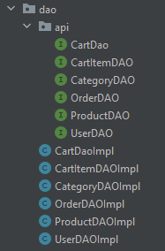
Figure 4. Dao implemetation.
DAO is defined by implementing a interface for entity class.

4.1.4 Business logic
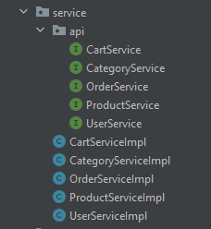
Figure 4. Service implemetation.
Table 2 is the table with description of each business-logic service in the application.
Service name | Description
CartService | Responsible for create cart for user, merge guest cart and user cart after auth, add/delete product in cart.
CategoryService | Responsible for adding and updating category.
OrderService | Responsible for creating order and update order.
ProductService | Responsible for creating and update product.
UserService | Responsible for adding, reading and updating users.

4.1.5 UI
UI is implemented with usage of JSP, JS and CSS. Navigation bar at the top is represented as separate .jsp file and included in all other page via tag <jsp:include>. Links displayed in navbar are depending on user’s authorities (for example, user won’t even see links to statistic). CSS styles are mostly Bootstrap 5. JS is just manually-written scripts.

5. Testing
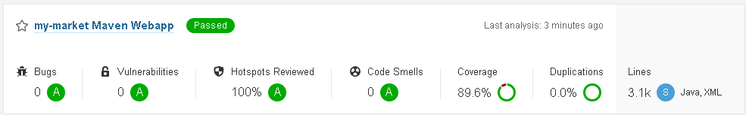
Figure 6. SonarQube scan result.
There are 94 JUnit tests with a total coverage of 89,6% for all application (DTO, entity and configs are excluded from the statistics).
Tests are split into packages and their names (both classes and test method) are self-explaining.
Controller tests are not unit-tests, these are more of an integration tests (they cover both controllers and service packages).

6. Features
- Flyway database migration.
- Custom validation for valid name, email,password, field match.
- Merge cart if user already have not empty cart.
- Internationalization
- Custom forbidden pages (403)

7. Security
Security is configured with Spring Security. All pages have restricted access. Additional security checks are done manually (for example, when editing user, in case someone will change page code to edit admin).

8. Logging
Logging is configured to display log information to log file.
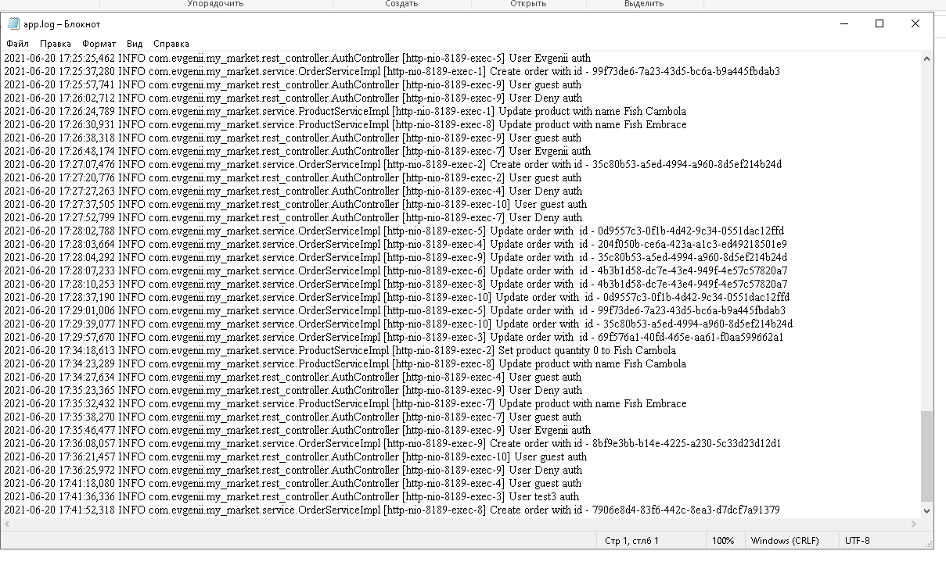
Figure 7. Log file.

9. Deployment
Testing, building and deployment is done by Maven. Projects is deployed to Tomcat Server with one call of “mvn install” command.

